Cat–cert
1학기 과제물

학과: ICT 공학계열
학번: 202221124
이름: 윤태호
제출기한:--
스터디 내용: WEB-6

<과제 내용>

[#조사] – rest api
- Representational state transfer

웹의 장점을 최대한 활용할 수 있는 아키텍처로써 rest를 발표하였음.

[#실습 1] - 정상작동시키기

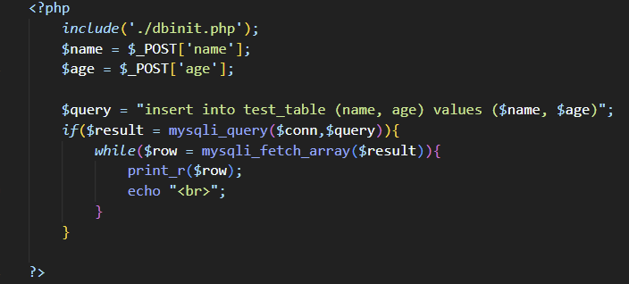
- mydb.php
<?php
include('./dbinit.php');
$name = '"'.$_POST['name'].'"';
$age = $_POST['age'];

$query = "insert into test_table (name, age) values ($name, $age)";
if ($result = mysqli_query($conn, $query)) {
while($row = mysqli_fetch_array($result)){
print_r($row);
echo "<br>";
}
}
?>

<html>
<head>
<h1> my db </h1>
</head>
<body>
<form method="POST" action="">
<table>
<tr>
<td> <input type= "input" name= "name" > </td>
<td> <input type= "input" name ="age" > </td>
</tr>
</table>
<input type ="submit" name ="제출">
</form>
</body>
</html>

> .dbinit 파일
<?php
$db_Host = "localhost";
$db_Id = "taeo0209";
$db_Pass = "2022Wnsldj!";
$db_Name = "taeo0209";

$conn = mysqli_connect($db_Host, $db_Id, $db_Pass, $db_Name);

mysqli_query($conn, "set session character_set_connection=utf8;");
mysqli_query($conn, "set session character_set_results=utf8;");
mysqli_query($conn, "set session character_set_client=utf8;");

mysqli_query($name, "set session character_set_connection=utf8;");
mysqli_query($name, "set session character_set_results=utf8;");
mysqli_query($name, "set session character_set_client=utf8;");

if(mysqli_connect_errno())
die('Connect Error: '.mysqli_connect_errno());
?>

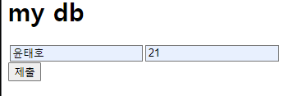
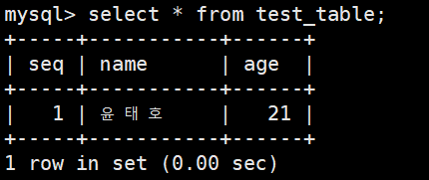

[#실습 2] -테이블에 출력하기
<html>
<head>
<style>
table,th, td {
border: 1px solid black;
}
</style>
</head>

<body>
<table style="border: 1px solid black">
<?php
include('./dbinit.php');
$query = "select * from Old_Member union select * from New_Member";
if($result = mysqli_query($conn, $query)) {
while($row = mysqli_fetch_array($result)) {
echo '<tr> <td>' . $row['Name'] . '</td>'. '<td>'.$row['School'].'</td>'. '<td>'.$row['Gender'].'</td>'. '<td>'.$row['EnterYear'].'</td>'. '<td>'.$row['Email'].'</td>'. '<td>'.$row['Phone'].'</td>'. '<td>'.$row['Birth'].'</td>'. '<td>'.$row['Grade']. '</td>'.'<td>'.$row['Score'].'</td>'. '<td>'.$row['Major'].'</td>'.'</tr>';
}
}
?>
</table>
</body>
</html>

(dbinit 파일은 실습1과 동일)

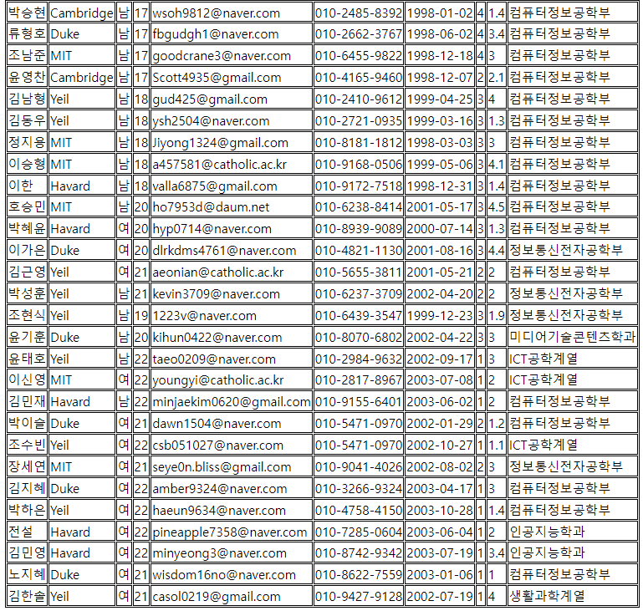

[#실습 3] - 테이블에 출력하기 (node.js)
App.js
const express = require("express");
const ejs = require("ejs");
const path = require("path");
const app = express();
const conn = require ("./db.js");

app.listen(8006, function() {
console.log("listening on port 8006");
});

app.use(express.urlencoded({ extended: false}));
app.set("views", path.join(__dirname, "views"));
app.set("views engine", "ejs");

app.get("/", function(req, res) {
var sql = "select * from Old_Member union select * from New_Member";
conn.query(sql, function (err,rows) {
if (err) console.log("query us it excuted. select fail\n" + err);
else res.render("index.ejs", {list: rows});
});
});

Index.ejs
<html>

<head>
<title> CAT-Security Node.js & MySQL</title>
<style>
table{
width: 70%;
text-align: center;
border-collapse: collapse;
border-top: 2px solid #ed0606;
}
th,
td {
border-bottom: 1px dashed #001763;
}
</style>
</head>
<body>
<h2>CAT-Security Node.js & MySQL</h2>
<div>
<table>
<thead>
<th> 이름 </th>
<th> 학교 </th>
<th> 전공 </th>
<th> 성별 </th>
<th> 입학년도 </th>
<th> 이메일 </th>
<th> 전화번호 </th>
<th> 생일 </th>
<th> 학년 </th>
</thead>
<tbody> <% for(var i of list) { %> <tr>
<td> <%= i.Name %></td>
<td> <%= i.School %></td>
<td> <%= i.Major %></td>
<td> <%= i.Gender %></td>
<td> <%= i.EnterYear %> </td>
<td> <%= i.Email %></td>
<td> <%= i.Phone %></td>
<td> <%= i.Birth %></td>
<td> <%= i.Grade %></td>
<td> <%= i.Score %></td>
</tr> <% } %> </tbody>
</table>
</div>
</body>
</html>

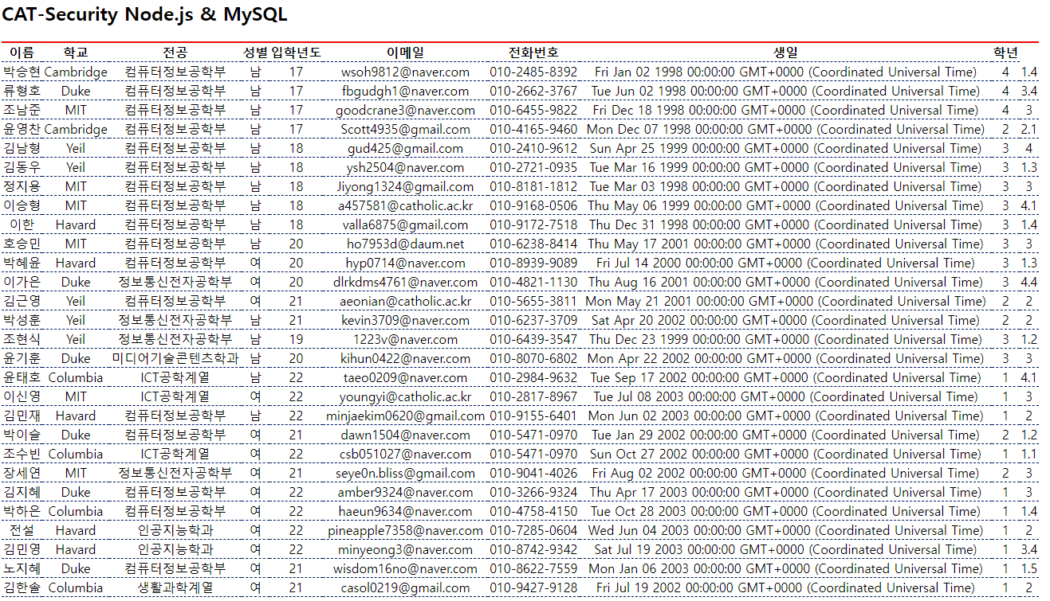

[#과제] – 방명록 만들기
- db.js
const mysql = require ("mysql");

const connection = mysql.createConnection( {
host: 'localhost',
user: 'taeo0209',
password: '2022Wnsldj!',
port: 3306,
database: 'taeo0209'
});

connection.connect( function (err) {
if (err) console.log(err);
else console.log('Connected!');
});
module.exports = connection;

- board.js
var express = require("express");
const ejs = require("ejs");
const path = require("path");
var app = express();
const conn = require("./db.js");

app.listen(8006, function () {
console.log("listening on port 8006");
});

app.use(express.urlencoded({ extended: false}));
app.set("views", path.join(__dirname, "views"));
app.set("view engine", "ejs");

app.get("/", function (req,res) {
var sql= "select * from board";
conn.query(sql, function (err, rows) {
if (err) console.log("query is not excuted. select fail!\n" + err);
else res.render("index.ejs", { list: rows});
});
});

app.get("/writepg", function (req,res) {
res.render("writepg.ejs");
});

app.post("/writepg", function (req,res) {
var body = req.body;
var name = body.myname;
var text = body.mywrite;
var title = body.title;

conn.query('insert into board(text,title, name) values ("' + text + '", "' + title + '", "' + name +'")', function(err, rows) {
if (err) console.log("query is not excuted. select fail!\n" + err);
else res.redirect("/");
});
});

app.get("/text/:seq", function (req, res) {
const i = req.params.seq;
var sql= 'select text from board where seq=?';
conn.query(sql, i, function (err, rows) {
if (err) console.log("query is not excuted. select fail!\n" + err);
else res.render("text.ejs", { list: rows});
})
})

app.post("/text/:seq", function (req, res) {
const i = req.params.seq;
var sql= 'delete from board where seq=?';
conn.query(sql, i, function (err, rows) {
if(err) console.log("query is not excuted. select fail\n" + err);
else res.redirect("/");
})
})

app.get("/fix", function (req,res) {
res.render("fix.ejs");
});
app.post("/fix", function (req,res) {
var body = req.body;
var name = body.myname;
var text = body.mywrite;
var title = body.title;

conn.query('update board set text = "' + text + '"', function(err, rows) {
if (err) console.log("query is not excuted. select fail!\n" + err);
else res.redirect("/");
});
});

인덱스
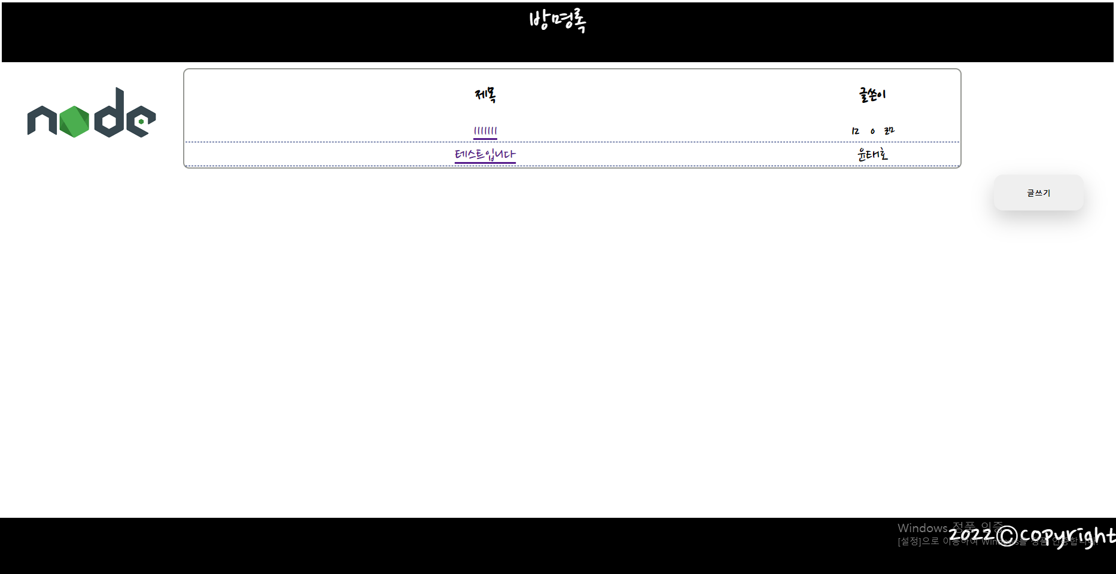
- index.ejs 파일
<html>
<head>
<link rel="preconnect" href="https://fonts.googleapis.com">
<link rel="preconnect" href="https://fonts.gstatic.com" crossorigin>
<link href="https://fonts.googleapis.com/css2?family=Nanum+Pen+Script&display=swap" rel="stylesheet">

<link rel="preconnect" href="https://fonts.googleapis.com">
<link rel="preconnect" href="https://fonts.gstatic.com" crossorigin>
<link href="https://fonts.googleapis.com/css2?family=Nanum+Pen+Script&display=swap" rel="stylesheet">
<style>
table{
font-family: 'Nanum Pen Script', cursive;
font-size: 30px;
width: 70%;
text-align: center;
border: 2px solid #959792;
border-radius: 10px;
margin: 10px;
}

td {
border-bottom: 1px dashed #001763;
}
th {
border-radius: 10%;
}
.write {
margin-right: 50px;
width: 150px;
height: 60px;
position: relative;
border: none;
display: inline-block;
padding: 15px 30px;
border-radius: 15px;
font-family: "paybooc-Light", sans-serif;
box-shadow: 0 15px 35px rgba(0, 0, 0, 0.2);
text-decoration: none;
font-weight: 600;
transition: 0.25s;
}
.container1 {
width: 100%;
height: 100px;
margin: 0 auto;
position: relative;
background-color: rgb(0, 0, 0);
top: 0;
font-family: 'Nanum Pen Script', cursive;
color: white;
font-size: 50px;
}
.container2 {
font-family: 'Nanum Pen Script', cursive;
width: 100%;
height: 100px;
margin: 0 auto;
position: absolute;
background-color: rgb(0, 0, 0);
left: 0;
bottom: 0;
color: white;
font-size: 50px;
}
</style>
</head>
<div class="container1"> 방명록 </div>
<body align="center" >
<img align ="left" src = 'https://encrypted-tbn0.gstatic.com/images?q=tbn:ANd9GcS9qtbtMOCRg_1gc9WZTSAPYIaIe-vqQ2GyZw&usqp=CAU'>
<table>
<thead>
<th width="1000px" height="80px"> 제목 </th>
<th> 글쓴이 </th>
</thead>
<tbody> <% for(var i of list) { %> <tr>
<td> <a href="/text/<%= i.seq %>" role="button" > <%= i.title %> </a> </td>
<td> <%= i.name %> </td>
</tr> <% } %> </tbody>
</table>
<div align="right"> <button class="write" type = "button" onclick="location.href='writepg'"> 글쓰기 </button></div>
<div align="right" class="container2" > 2022©Copyright </div>
</body>
</html>

글 작성 페이지.
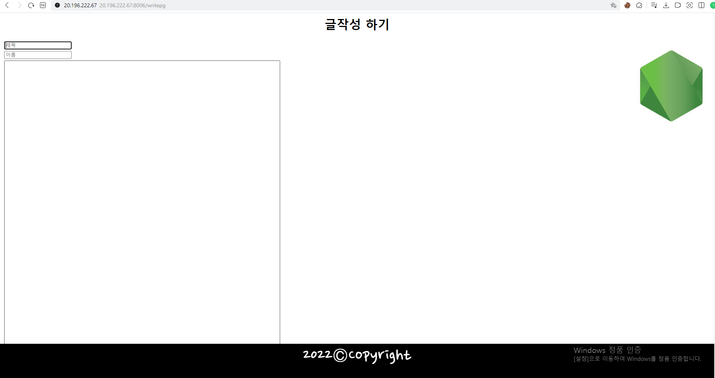

- writepg.ejs
<html>
<head>
<link rel="preconnect" href="https://fonts.googleapis.com">
<link rel="preconnect" href="https://fonts.gstatic.com" crossorigin>
<link href="https://fonts.googleapis.com/css2?family=Nanum+Pen+Script&display=swap" rel="stylesheet">
<style>
table{
width: 70px;
border: 3px saddlebrown;
}
.container2 {
font-family: 'Nanum Pen Script', cursive;
width: 100%;
height: 100px;
margin: 0 auto;
position: absolute;
background-color: rgb(0, 0, 0);
left: 0;
bottom: 0;
color: white;
font-size: 50px;
}
</style>
<h1> 글작성 하기 </h1>
</head>
<body align="center">
<form method="post" action="">
<table>
<tr> <td> <input type = "text" name = "title" placeholder="제목" > </td> </tr>
<tr> <td> <input type="text" name="myname" placeholder="이름"> </td> </tr>
<tr> <td> <textarea rows="50" cols="100" name ="mywrite" value="input"> </textarea> </td> </tr>
<input align="right" type ="image" src="https://encrypted-tbn0.gstatic.com/images?q=tbn:ANd9GcRl1NtmzUjee4gFEqlBhsgoSWWCgiOEJuPSjA&usqp=CAUname=" >
</table>
</form>
<div class="container2" > 2022©Copyright </div>
</body>
</html>

글 조회 페이지

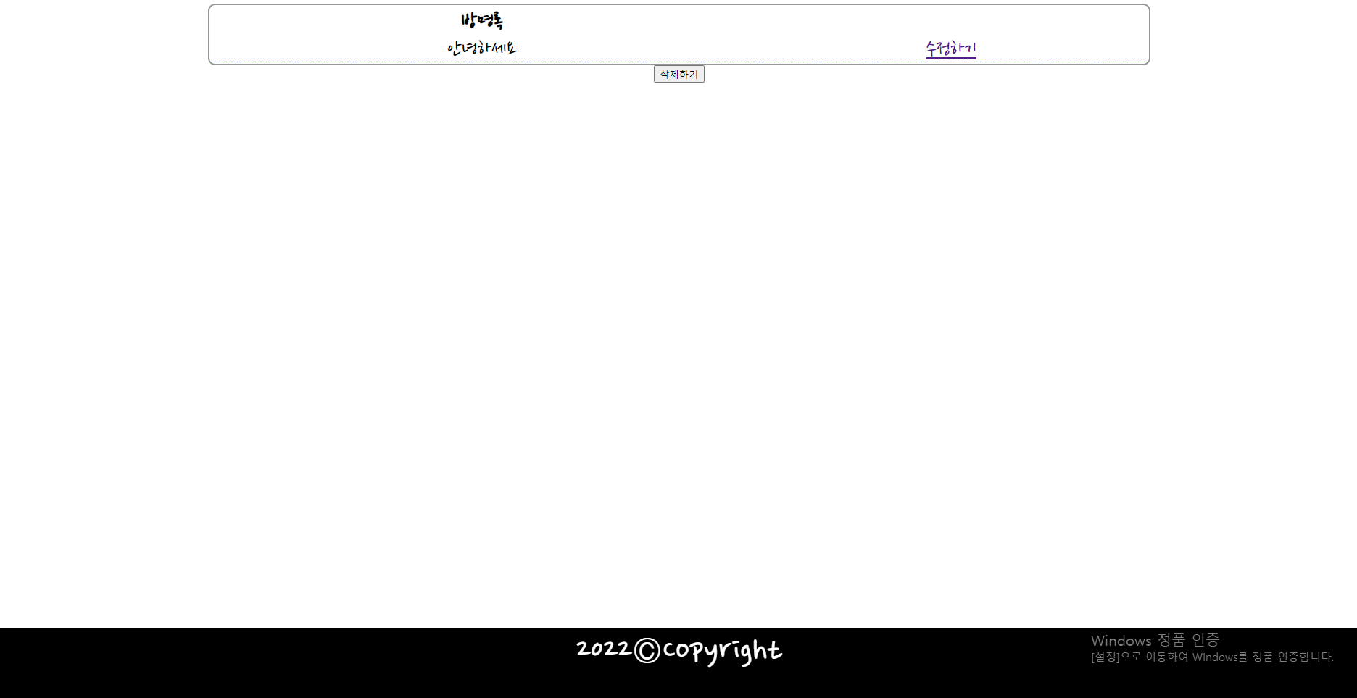

- text.ejs
<html>
<head>
<link rel="preconnect" href="https://fonts.googleapis.com">
<link rel="preconnect" href="https://fonts.gstatic.com" crossorigin>
<link href="https://fonts.googleapis.com/css2?family=Nanum+Pen+Script&display=swap" rel="stylesheet">
<style>
table{
font-family: 'Nanum Pen Script', cursive;
font-size: 30px;
width: 70%;
text-align: center;
border: 2px solid #959792;
border-radius: 10px;

}
.container2 {
font-family: 'Nanum Pen Script', cursive;
width: 100%;
height: 100px;
margin: 0 auto;
position: absolute;
background-color: rgb(0, 0, 0);
left: 0;
bottom: 0;
color: white;
font-size: 50px;
}
td {
border-bottom: 1px dashed #001763;
}
</style>
</head>
<body align="center">
<table align="center">
<thead>
<th> 방명록 </th>
</thead>
<tbody> <% for(var i of list) { %> <tr>
<td> <%= i.text %> </td>
<td> <a href="/fix" role="button" > 수정하기 </a> </td>
</tr> <% } %> </tbody>
</table>
<form method="POST" action="">
<div> <button type = "submit" name = "rm" > 삭제하기 </button>
</form>
<div class="container2" > 2022©Copyright </div>
</body>
</html>

글 수정 페이지
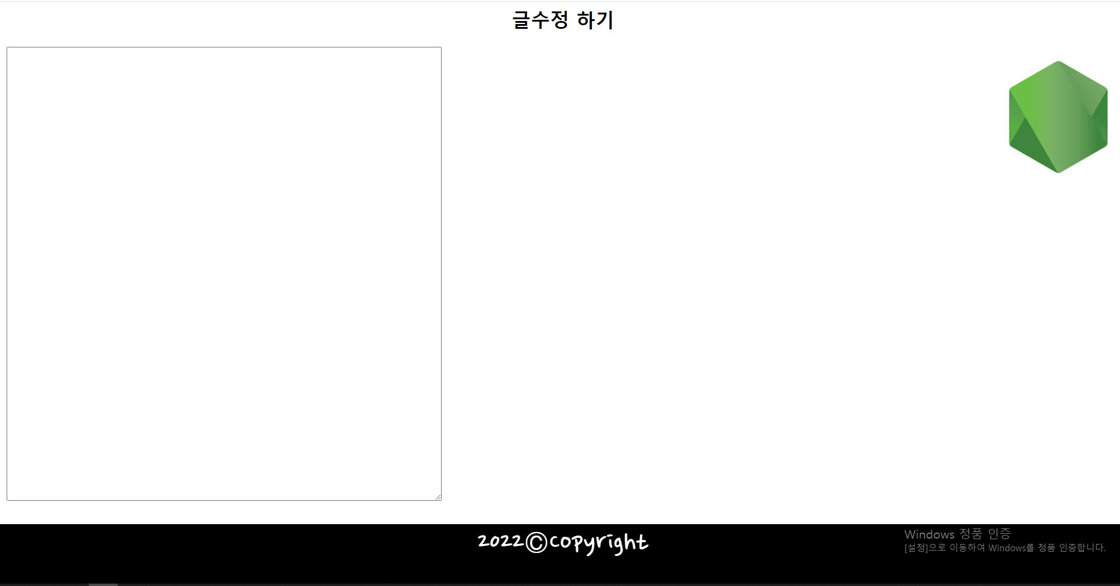

- fix.ejs
<html>
<head>
<link rel="preconnect" href="https://fonts.googleapis.com">
<link rel="preconnect" href="https://fonts.gstatic.com" crossorigin>
<link href="https://fonts.googleapis.com/css2?family=Nanum+Pen+Script&display=swap" rel="stylesheet">
<style>
table{
width: 70px;
border: 3px saddlebrown;
}
.container2 {
font-family: 'Nanum Pen Script', cursive;
width: 100%;
height: 100px;
margin: 0 auto;
position: absolute;
background-color: rgb(0, 0, 0);
left: 0;
bottom: 0;
color: white;
font-size: 50px;
}
</style>
<h1> 글수정 하기 </h1>
</head>
<body align="center">
<form method="post" action="">
<table>
<tr> <td> <textarea rows="50" cols="100" name ="mywrite" value="input"> </textarea> </td> </tr>
<input align="right" type ="image" src="https://encrypted-tbn0.gstatic.com/images?q=tbn:ANd9GcRl1NtmzUjee4gFEqlBhsgoSWWCgiOEJuPSjA&usqp=CAUname=" >
</table>
</form>
<div class="container2" > 2022©Copyright </div>
</body>
</html>

글 삭제 확인
